October 16, 2014

Dear Parent,

The purpose of this letter is to inform you of important changes to the PowerSchool Parent Portal. This resource makes it possible for you to check on your student’s grades, attendance and other information items.

Manufacturer upgrades to this parent portal option will require all parent users to create a new access account that will bring new features and capabilities for you to use. These features include:

- Single sign-on to view students in multiple schools
- Parent portal access for iPads and IPhones

The start date for these new features is November 12. When you log into the Parent Portal on that day you will need to create a new user account.

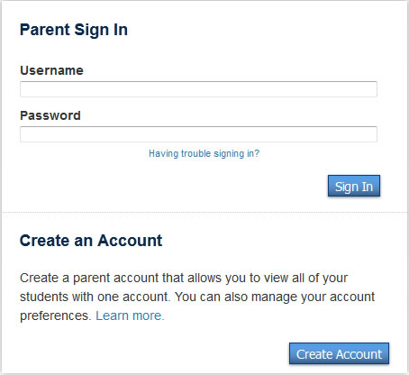
Please Note

- A Create Parent Account page will appear
  - Enter first name, last name, e-mail address
  - Enter desired user name – must not contain * & . @
  - Enter desired password – must be 6 characters long
- You will need to use your previous parent access ID and parent access password to link your new account with your student
  - Enter student’s first and last name
  - Enter parent access id and password

This change should be easy for you to implement. If you experience difficulties, please contact our Main Office.

